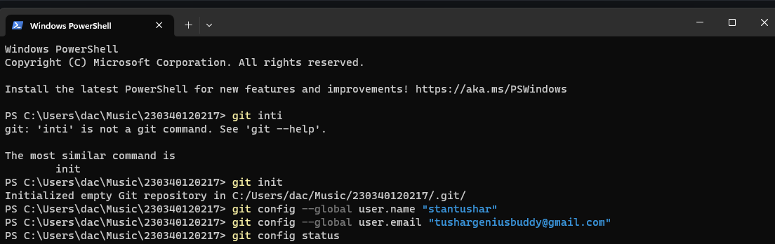

1. Initialize the folder with git repository
2. Then add the username and email of github account

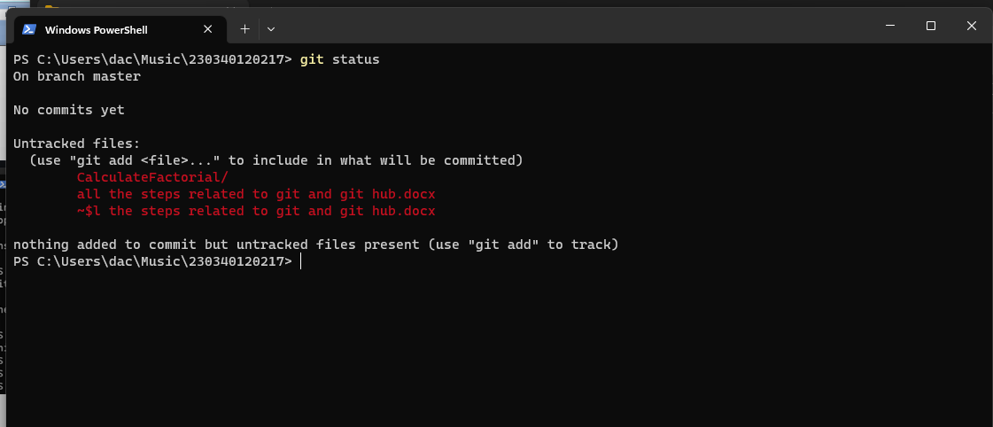

1. New file in unstage area
2. Add into the git staging area to

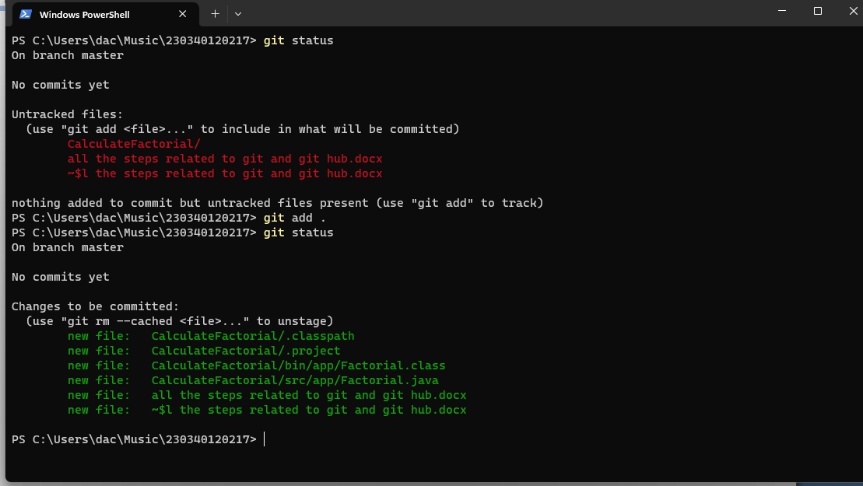

1. Added all the files in staging area
2. Now add the remote repository to connect local repository
3. 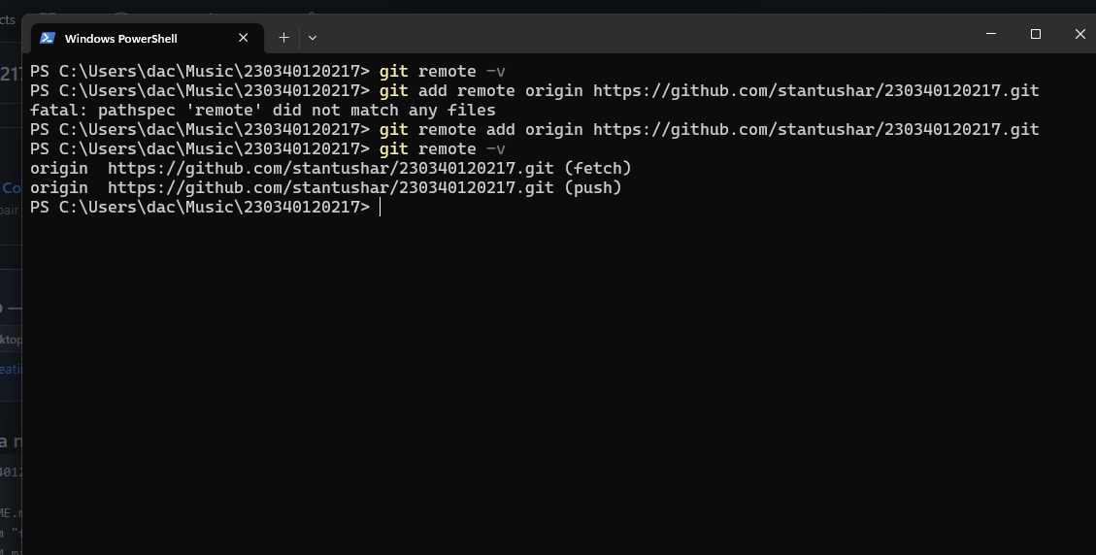
4. Added the remote url to connect remote repository of github to local git
5. Now commit the changes in local repository and push it to the remote repository
6. 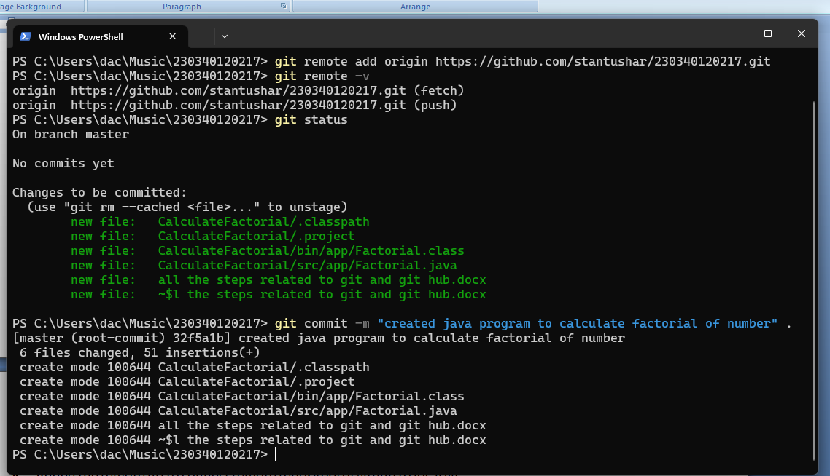

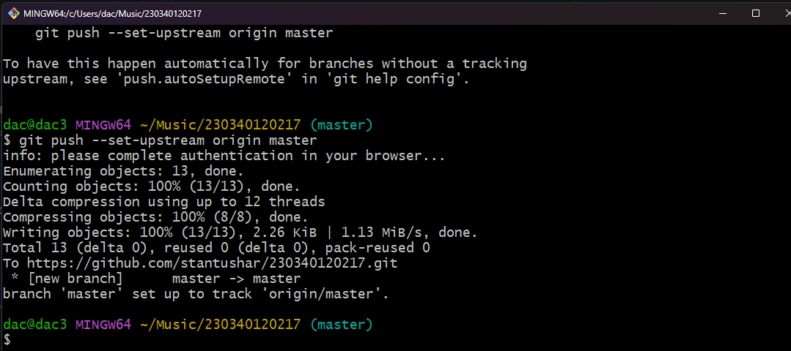

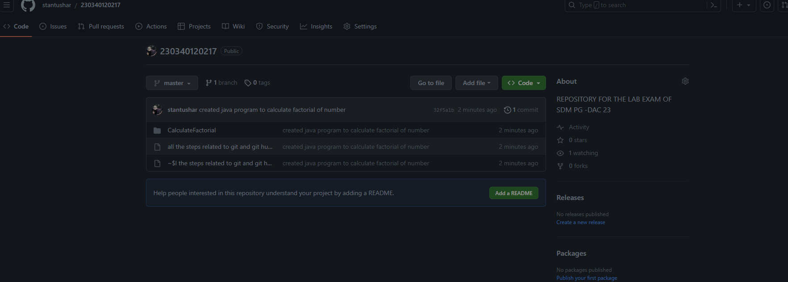

1. Changes pushed to Github

Repository Link : - <https://github.com/stantushar/230340120217.git>